Appendix S1

*Study site climate.—* To characterize differences in temperature and precipitation between wet and dry seasons, we recorded daily minimum/ maximum temperatures using a min/max thermometer and total rainfall using a rain gauge along the continental divide from Wet 2012 to Dry 2014. To determine differences in microhabitat temperature along riparian and terrestrial transects, we recorded hourly temperatures every 60 to 80 meters along each transect using Maxim Technologies’ ibuttons®.

Due to consistency between seasons, we did not include temperature or rainfall as covariates in any parts of the disease-structured generalized *N*-mixture model. Rather, when appropriate, we included a seasonal covariate. The total seasonal rainfall during the 2012 and 2013 wet seasons was 2599.80 mm and 2459.2 mm, respectively, while the 2013 and 2014 dry seasons experienced 1202.1 mm and 1214.6 mm (Figure S1). The average daily minimum/maximum temperatures during the 2012 and 2013 wet seasons were 19.75°C /26.27°C and 19.70°C /28.56°C, respectively, while the 2013 and 2014 dry seasons were 19.57°C /23.98°C and 18.57°C /25.14°C (Figure S1). Temperatures along stream and trail transects were similar within a season, and mean maximum daily temperature was higher during the wet season than the dry season (Figure S2 & S3).

*Testing for population closure and spatial autocorrelation.—* To test for population closure between surveys, we subtracted the number of observed animals at each site between the first set of surveys (3 consecutive night surveys) and the last set of surveys (3 to 4 consecutive night surveys) during (A) wet 2012, (B) dry 2013, (C) wet 2013, and (D) dry 2014 seasons (Table S1). We exclude years 2010 and 2011 because all surveys were conducted on consecutive nights (i.e., there was no split in the number of surveys; Figure S4).

We also tested for spatial autocorrelation because all sites were adjacent. We used the raw count data and used Moran’s *I*. We found no autocorrelation, except 2014 dry season, likely because the number of frogs found in each site was fairly uniform (e.g., Fig. S6).

*Simulating variation in population demographic parameters.—* We simulated data for 32 species where variation among species differed among vital rates (Fig. S5). We used the function rnorm() in base R (R Core Team 2015) with 32 values randomly drawn from a normal distribution with a mean of 2.94 (probability scale= 0.95), and we varied the standard deviation (i.e., sd = 0, 1, 2, or 4). When species within the community differ greatly in demographic estimates (i.e., high σ2 values), there is high variation in the estimated parameter values for survival and gains, whereas if species have similar demographic estimates (i.e., low σ2 values), there is low variation in parameter estimates (Figure S5).

*Testing the Poisson assumption.—* To determine if a Poisson distribution sufficiently described the count data, we visualized the data for the first season (2010 wet) using a histogram (Figure S6). We also calculated the mean and variance of amphibian captures across the site (i.e., 99- 20 m sections). We found that the mean number of amphibians captured was 0.21, the variance was 0.31, and the mean to variance ratio was 0.68.

*Raw data.—* We visualized the raw number of amphibians captured each season and calculate the total naïve *Bd* prevalence across the entire community of amphibians (Figure S7) and per species (Table S3). The number of observed amphibians widely ranged among seasons from 17 to 469 (Figure S7). We do not display this data in the manuscript because they are uncorrected counts for imperfect host and pathogen detection.

*Size distribution.—* To determine if we could add sex structure to the model, we visualized the snout-to-vent length (SVL) of captures for several species with greater than 15 captures throughout the study. We found very few tadpoles or juveniles of any species (Fig. S8); therefore, we were not able to include this structure in the model.

Macintosh HD:Users:Cici:Dropbox:PhD_cope:Site_rainfall.pdf

Macintosh HD:Users:Cici:Dropbox:PhD_cope:Site_temperature.pdf

Figure S1 Weather patterns at the site from a weather station located along the continental divide. Black bars represent total rainfall (cm) on the left y-axis, while the red (maximum daily temperature) and blue (minimum daily temperature) lines correspond to the daily extreme temperature on the right y-axis.

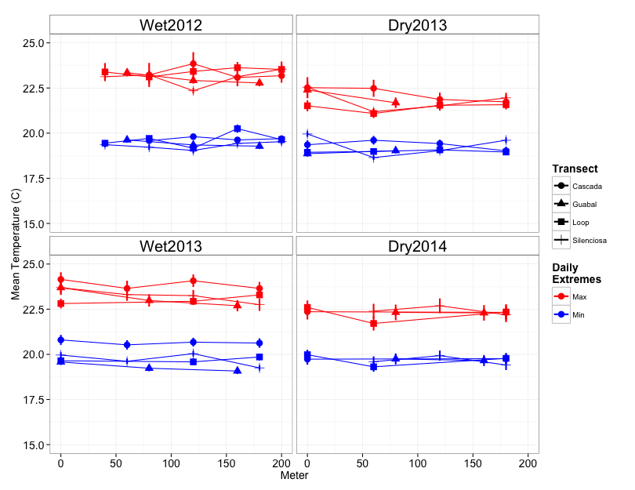

Figure S2 Summary of daily minimum (blue) and maximum (red) habitat temperatures along each stream transect each season surveyed. Points represent means and bars indicate standard error.

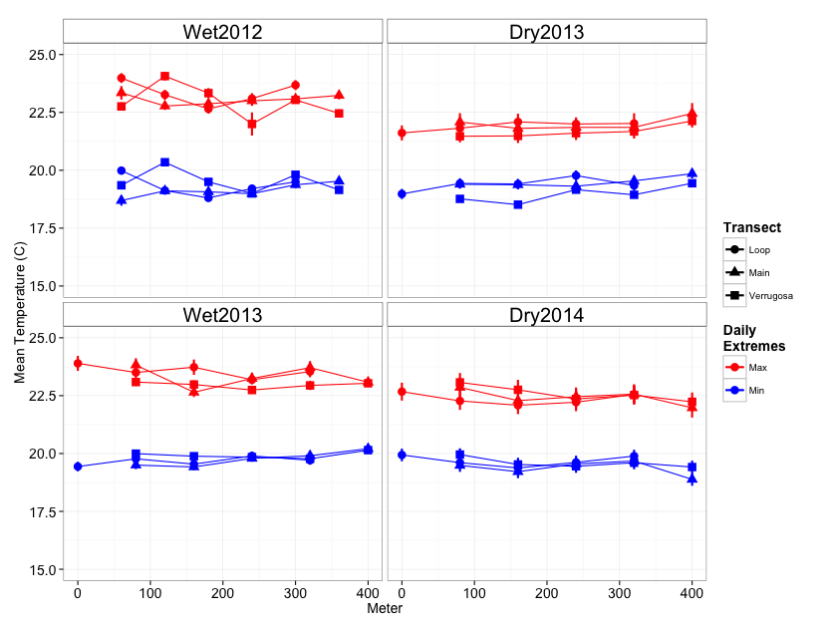

Figure S3 Summary of daily minimum (blue) and maximum (red) habitat temperatures along each trail transect each season surveyed. Points represent means and bars indicate standard error.

Macintosh HD:Users:Cici:GitHub:2010to2014ElCope:Closure Assumption:Figures:Grouped_difference_18_july_2017.pdf

Figure S4. To test for population closure between surveys, we calculated the difference in observed abundance for each site between the first set of surveys and the last set of surveys during (A) wet 2012, (B) dry 2013, (C) wet 2013, and (D) dry 2014 seasons. We exclude years 2010 and 2011 because all surveys were conducted on consecutive nights.

Macintosh HD:Users:Cici:Desktop:June 2017 Dail Model Ecology:Variance_fig_2Aug.pdf

Figure S5. We simulated data for 32 species where variation among species differed among vital rates (Panel A, B). The x-axis shows the standard deviation used for each simulation (i.e., Panel A survival and Panel B recruitment). When species within the community differ greatly in demographic estimates (i.e., high σ2 values), there is high variation in the estimated parameter values for survival and gains, whereas if species have similar demographic estimates (i.e., low σ2 values), there is low variation in parameter estimates. The boxplot represents the quantiles (i.e., 25th, 50th, 75th), and the golden points show the simulated species-specific demographic values.



Figure S6. Histogram of the number of amphibians captured during the first season (wet 2010) at each 20 m site. The mean number of amphibians was 0.21, the variance was 0.31, and the mean to variance ratio was 0.68.

Macintosh HD:Users:Cici:Dropbox:DiseaseNmix_NO_detection:Send to Elise:Fig2_no_detection.pdf

Figure S7. (A) The raw count data for infected and uninfected amphibians, uncorrected for imperfect host or pathogen detection. The y-axis represents total raw counts of amphibians across all 7 transects during each season. The thick black line represents individuals that were infected, and the thick gray line represent individuals that were uninfected. (B) The raw estimated pathogen prevalence (i.e., the proportion of infected individuals) in the population.



Figure S8. Histograms of the snout-to-vent length (SVL; x-axis) of several species with greater than 15 captures throughout the study. Notice the bimodal curve for *Pristimantis cruentus* and *Pristimantis cerasinus*, which both have sexually dimorphic sizes for males and females; but juvenile females may be included in the smaller sizes. For most other species, there is a normal distribution of sizes, suggesting that males and females overlap greatly in size. We never captured individuals at small sizes for these individuals.

Table S1. Summary of survey effort across transects and primary seasons (i.e., Wet 2010 to Dry 2014). Values represent number of replicate surveys performed at each site. All sites were sampled at least once each primary period, expect for Loop Trail in 2010.

|  |  |  |  |  |  |  |  |
| --- | --- | --- | --- | --- | --- | --- | --- |
|  |  | Year | | | | | |
| Transect | Meter | 2010 Wet | 2011 Wet | 2012 Wet | 2012-13 Dry | 2013 Wet | 2013-14 Dry |
| Cascada | 0 | 1 | 3 | 8 | 7 | 7 | 7 |
| Cascada | 100 | 1 | 3 | 8 | 7 | 7 | 7 |
| Cascada | 120 | 1 | 3 | 8 | 7 | 7 | 7 |
| Cascada | 140 | 1 | 3 | 8 | 7 | 7 | 7 |
| Cascada | 160 | 1 | 3 | 8 | 7 | 7 | 7 |
| Cascada | 180 | 1 | 3 | 8 | 7 | 7 | 7 |
| Cascada | 20 | 1 | 3 | 8 | 7 | 7 | 7 |
| Cascada | 40 | 1 | 3 | 8 | 7 | 7 | 7 |
| Cascada | 60 | 1 | 3 | 8 | 7 | 7 | 7 |
| Cascada | 80 | 1 | 3 | 8 | 7 | 7 | 7 |
| Guabal | 0 | 2 | 3 | 8 | 7 | 7 | 7 |
| Guabal | 100 | 2 | 3 | 8 | 7 | 7 | 7 |
| Guabal | 120 | 2 | 3 | 8 | 7 | 7 | 7 |
| Guabal | 140 | 2 | 3 | 8 | 7 | 7 | 7 |
| Guabal | 160 | 2 | 3 | 8 | 7 | 7 | 7 |
| Guabal | 180 | 2 | 3 | 8 | 7 | 7 | 7 |
| Guabal | 20 | 2 | 3 | 8 | 7 | 7 | 7 |
| Guabal | 40 | 2 | 3 | 8 | 7 | 7 | 7 |
| Guabal | 60 | 2 | 3 | 8 | 7 | 7 | 7 |
| Guabal | 80 | 2 | 3 | 8 | 7 | 7 | 7 |
| LoopStream | 0 | 3 | 3 | 7 | 6 | 7 | 8 |
| LoopStream | 100 | 3 | 3 | 7 | 6 | 7 | 8 |
| LoopStream | 120 | 3 | 3 | 7 | 6 | 7 | 8 |
| LoopStream | 140 | 3 | 3 | 7 | 6 | 7 | 8 |
| LoopStream | 160 | 3 | 3 | 7 | 6 | 7 | 8 |
| LoopStream | 180 | 3 | 3 | 7 | 6 | 7 | 8 |
| LoopStream | 20 | 3 | 3 | 7 | 6 | 7 | 8 |
| LoopStream | 40 | 3 | 3 | 7 | 6 | 7 | 8 |
| LoopStream | 60 | 3 | 3 | 7 | 6 | 7 | 8 |
| LoopStream | 80 | 3 | 3 | 7 | 6 | 7 | 8 |
| LoopTrail | 0 | 0 | 1 | 7 | 7 | 6 | 7 |
| LoopTrail | 100 | 0 | 1 | 7 | 7 | 6 | 7 |
| LoopTrail | 120 | 0 | 1 | 7 | 7 | 6 | 7 |
| LoopTrail | 140 | 0 | 1 | 7 | 7 | 6 | 7 |
| LoopTrail | 160 | 0 | 1 | 7 | 7 | 6 | 7 |
| LoopTrail | 180 | 0 | 1 | 7 | 7 | 6 | 7 |
| LoopTrail | 20 | 0 | 1 | 7 | 7 | 6 | 7 |
| LoopTrail | 200 | 0 | 1 | 7 | 7 | 6 | 7 |
| LoopTrail | 220 | 0 | 1 | 7 | 7 | 6 | 7 |
| LoopTrail | 240 | 0 | 1 | 7 | 7 | 6 | 7 |
| LoopTrail | 260 | 0 | 1 | 7 | 7 | 6 | 7 |
| LoopTrail | 280 | 0 | 1 | 7 | 7 | 6 | 7 |
| LoopTrail | 300 | 0 | 1 | 7 | 7 | 6 | 7 |
| LoopTrail | 320 | 0 | 1 | 7 | 7 | 6 | 7 |
| LoopTrail | 340 | 0 | 1 | 7 | 7 | 6 | 7 |
| LoopTrail | 360 | 0 | 1 | 7 | 7 | 6 | 7 |
| LoopTrail | 40 | 0 | 1 | 7 | 7 | 6 | 7 |
| LoopTrail | 60 | 0 | 1 | 7 | 7 | 6 | 7 |
| LoopTrail | 80 | 0 | 1 | 7 | 7 | 6 | 7 |
| MainTrail | 0 | 1 | 1 | 7 | 7 | 6 | 8 |
| MainTrail | 100 | 1 | 1 | 7 | 7 | 6 | 8 |
| MainTrail | 120 | 1 | 1 | 7 | 7 | 6 | 8 |
| MainTrail | 140 | 1 | 1 | 7 | 7 | 6 | 8 |
| MainTrail | 160 | 1 | 1 | 7 | 7 | 6 | 8 |
| MainTrail | 180 | 1 | 1 | 7 | 7 | 6 | 8 |
| MainTrail | 20 | 1 | 1 | 7 | 7 | 6 | 8 |
| MainTrail | 200 | 1 | 1 | 7 | 7 | 6 | 8 |
| MainTrail | 220 | 1 | 1 | 7 | 7 | 6 | 8 |
| MainTrail | 240 | 1 | 1 | 7 | 7 | 6 | 8 |
| MainTrail | 260 | 1 | 1 | 7 | 7 | 6 | 8 |
| MainTrail | 280 | 1 | 1 | 7 | 7 | 6 | 8 |
| MainTrail | 300 | 1 | 1 | 7 | 7 | 6 | 8 |
| MainTrail | 320 | 1 | 1 | 7 | 7 | 6 | 8 |
| MainTrail | 340 | 1 | 1 | 7 | 7 | 6 | 8 |
| MainTrail | 360 | 1 | 1 | 7 | 7 | 6 | 8 |
| MainTrail | 380 | 1 | 1 | 7 | 7 | 6 | 8 |
| MainTrail | 40 | 1 | 1 | 7 | 7 | 6 | 8 |
| MainTrail | 60 | 1 | 1 | 7 | 7 | 6 | 8 |
| MainTrail | 80 | 1 | 1 | 7 | 7 | 6 | 8 |
| Silenciosa | 0 | 1 | 3 | 6 | 7 | 7 | 8 |
| Silenciosa | 100 | 1 | 3 | 6 | 7 | 7 | 8 |
| Silenciosa | 120 | 1 | 3 | 6 | 7 | 7 | 8 |
| Silenciosa | 140 | 1 | 3 | 6 | 7 | 7 | 8 |
| Silenciosa | 160 | 1 | 3 | 6 | 7 | 7 | 8 |
| Silenciosa | 180 | 1 | 3 | 6 | 7 | 7 | 8 |
| Silenciosa | 20 | 1 | 3 | 6 | 7 | 7 | 8 |
| Silenciosa | 40 | 1 | 3 | 6 | 7 | 7 | 8 |
| Silenciosa | 60 | 1 | 3 | 6 | 7 | 7 | 8 |
| Silenciosa | 80 | 1 | 3 | 6 | 7 | 7 | 8 |
| Verrugosa | 0 | 1 | 1 | 7 | 7 | 5 | 8 |
| Verrugosa | 100 | 1 | 1 | 7 | 7 | 5 | 8 |
| Verrugosa | 120 | 1 | 1 | 7 | 7 | 5 | 8 |
| Verrugosa | 140 | 1 | 1 | 7 | 7 | 5 | 8 |
| Verrugosa | 160 | 1 | 1 | 7 | 7 | 5 | 8 |
| Verrugosa | 180 | 1 | 1 | 7 | 7 | 5 | 8 |
| Verrugosa | 20 | 1 | 1 | 7 | 7 | 5 | 8 |
| Verrugosa | 200 | 1 | 1 | 7 | 7 | 5 | 8 |
| Verrugosa | 220 | 1 | 1 | 7 | 7 | 5 | 8 |
| Verrugosa | 240 | 1 | 1 | 7 | 7 | 5 | 8 |
| Verrugosa | 260 | 1 | 1 | 7 | 7 | 5 | 8 |
| Verrugosa | 280 | 1 | 1 | 7 | 7 | 5 | 8 |
| Verrugosa | 300 | 1 | 1 | 7 | 7 | 5 | 8 |
| Verrugosa | 320 | 1 | 1 | 7 | 7 | 5 | 8 |
| Verrugosa | 340 | 1 | 1 | 7 | 7 | 5 | 8 |
| Verrugosa | 360 | 1 | 1 | 7 | 7 | 5 | 8 |
| Verrugosa | 380 | 1 | 1 | 7 | 7 | 5 | 8 |
| Verrugosa | 40 | 1 | 1 | 7 | 7 | 5 | 8 |
| Verrugosa | 60 | 1 | 1 | 7 | 7 | 5 | 8 |
| Verrugosa | 80 | 1 | 1 | 7 | 7 | 5 | 8 |

Table S2. Summary results of spatial autocorrelation analysis of amphibian counts at each 20m site each season-year combination using the Moran.I() function in the package *ape*.

|  |  |  |  |  |
| --- | --- | --- | --- | --- |
| Season-year | Moran's I | Expected I | Standard deviation | *p*-value |
| 2010W | 0.15 | -0.10 | 0.10 | 0.12 |
| 2011W | 0.03 | -0.10 | 0.09 | 0.64 |
| 2012W | 0.08 | -0.10 | 0.09 | 0.33 |
| 2013D | 0.15 | -0.10 | 0.09 | 0.08 |
| 2013W | 0.13 | -0.10 | 0.09 | 0.13 |
| 2014D | 0.26 | -0.10 | 0.09 | 0.01 |

Table S3. Capture-mark-recapture summary for eight focal amphibian species across four seasons in two years. ‘New’ represents the number of new individuals marked each season. ‘Recap’ indicates the number of individuals recaptured each season.

|  |  |  |  |  |  |  |  |  |
| --- | --- | --- | --- | --- | --- | --- | --- | --- |
|  |  | Wet | Dry | | Wet | | Dry | |
|  |  | 2012 | 2013 | | 2013 | | 2014 | |
| Genus | Species | New | New | Recap | New | Recap | New | Recap |
| *Espadarana* | *prosoblepon* | 81 | 37 | 74 | 59 | 158 | 72 | 103 |
| *Pristimantis* | *cerasinus* | 67 | 19 | 2 | 24 | 2 | 17 | 1 |
| *Pristimantis* | *cruentus* | 71 | 9 | 0 | 7 | 0 | 10 | 1 |
| *Pristimantis* | *pardalis* | 1 | 0 | 0 | 0 | 0 | 0 | 0 |
| *Sachatamia* | *albomaculata* | 26 | 15 | 9 | 28 | 28 | 11 | 11 |
| *Diasporus* | *orange* | 0 | 3 | 1 | 0 | 0 | 10 | 2 |
| *Hyloscurtis* | *palmeri* | 1 | 0 | 0 | 0 | 0 | 2 | 2 |
| *Hyalinobatrachium* | *colymbiphyllum* | 7 | 0 | 0 | 1 | 5 | 0 | 0 |

Table S4. Raw Bd infection prevalence among species with greater than 15 captures per year.

|  |  |  |  |
| --- | --- | --- | --- |
| Species | Year | Prevalence | Sample size |
| *Espadarana prosoblepon* | 2014 | 0.07 | 150 |
| *Sachatamia albomaculata* | 2014 | 0.11 | 19 |
| *Craugastor crassidigitus* | 2013 | 0.15 | 20 |
| *Hyalinobatrachium colymbiphyllum* | 2012 | 0.17 | 18 |
| *Espadarana prosoblepon* | 2013 | 0.22 | 252 |
| *Pristimantis cerasinus* | 2013 | 0.22 | 77 |
| *Espadarana prosoblepon* | 2011 | 0.23 | 52 |
| *Espadarana prosoblepon* | 2012 | 0.25 | 162 |
| *Pristimantis cruentus* | 2012 | 0.25 | 113 |
| *Diasporus orange* | 2013 | 0.25 | 24 |
| *Pristimantis cerasinus* | 2014 | 0.26 | 34 |
| *Pristimantis cruentus* | 2013 | 0.27 | 30 |
| *Sachatamia albomaculata* | 2013 | 0.28 | 68 |
| *Espadarana prosoblepon* | 2010 | 0.29 | 21 |
| *Pristimantis pardalis* | 2012 | 0.29 | 24 |
| *Sachatamia albomaculata* | 2012 | 0.34 | 35 |
| *Pristimantis cerasinus* | 2012 | 0.39 | 88 |
| *Pristimantis cruentus* | 2014 | 0.56 | 25 |

References

R Core Team. (2015). R: A language and environment for statistical computing. R Foundation for Statistical Computing, Vienna, Austria. URL http://www.R-project.org/.